Ch 12 nb v2 Social Study Guide
- For social psychologists, it is all about “The Power of the S_______________”
- If I wonder “why did she do that?”, then I am seeking an A _ _ _ _ _ _ _ _ _ n (an explanation for why someone did something)
- Nancy was late because a car ran a red light and hit her. Is this a situational (external) or dispositional attribution?
- Enuice was late because she is rude and uncaring. Is this a situational or dispositional attribution?
- A student in your workgroup didn’t show up for your meeting. If you make the fundamental attribution error (FAE), what might you conclude? (know what the FAE is)
- What was the “quizmaster” study and why was it mentioned?
- What was the text’s conclusion about whether or not the FAE is a universal phenomenon?
- What is the self serving bias? Assume I didn’t change my oil regularly and my car broke down. If I am guilty of the self-serving bias, which explanation would I make: the shop didn’t tell me it was time, or I just forgot.
- OK, I get the FAE. But the text says the actor-observer bias is different when we are judging our own behavior (tend to focus on situational factors). Then the text says that according to the self serving bias we use dispositional (NOT situational) explanations for our failures. So let’s ignore the Actor- Observer Bias.
- Sally believes in the “just-world” hypothesis and Randy does not. Both are jurors on a rape trial. All else equal, which is likely to give the rapist a harsher sentence? Why? (hint: harsher sentence is associated with more blame to the victim)(know what the just-world hypothesis is and consequences of a belief in it)
- As a professor, I’m expected to act certain ways. As a student, you are expected to act certain ways. This highlights the role of S______ R________s in determining our behavior.
- If I go to the supermarket and go to the express checkout with 52 items, I’ll get a lot of nasty looks and maybe even some nasty comments. This could be explained because we all feel compelled to act according to S____________ N______________. (note: I’ve always had some trouble conceptualizing a true and distinct difference between #11 and #12. I mean couldn’t one say about #12 that I got nasty looks because I was violating expectations of what is expected in my role as shopper?)
- When we go into a restaurant, we all have knowledge of how the experience should unfold: pick a table, look at the menu, make a selection, eat the meal, pay for the meal. When we follow an expected sequence of behaviors in a particular setting, we are talking about following a S__________.
- The Stanford Prison Study helps us understand which of the following?
  - Why I ate my meal so quickly last night --- as if I was in prison and had little time.
  - Why the guards at the Abu Ghraib prison acted as they did.
  - Why prisoners who are released suffer such high recidivism rates.
- Cognitive dissonance is a discrepancy between your a _ _ _ _ _ _ _ (or belief)
and your b _ _ _ _ _ _ _.
- In the classic study of cognitive dissonance, subjects were paid either $20 or $1 to lie about how interesting a task was. Which group was more likely to come to believe they actually liked the task after all? (in other words, which group had greater attitude change?)
- The text on page 427 discuss the “foot-in-the-door”. Your handout discusses that as well as a couple others: Door-in-the-face, and “Reciprocity”. Which one helps explain why the March of Dimes sends return address labels in the same envelope that asks for a donation?
- For each scenario, identity the compliance/persuasion technique
  - Child has a train set. Child asks mom for a little stop sign to go with the train set and gets it. Child then asks mom for 3 new train cars and gets it. If the child had never asked and received the stop sign first, they would have been much less likely to have received the train cars.
  - Child has a train set. Child asks for 8 new train cars and is denied. Child then asks for 3 new train cars and gets them. If the child had never asked (and been rejected) for the 8 cars, they would have been much less likely to have received the 3 train cars.
- Who are confederates in a research setting?
- Who was the researcher who asked subjects to make judgments as to which line matched a “standard” line in an attempt to see how many would go along with an incorrect majority? What principle was he studying?
- What percent of Milgram’s subjects went all the way?
- What is group think?
- When an individual’s performance is influenced by the presence of others we call it
S_________ I__________.
- When you participate in a group project you could easily find that your classmates seem to be slacking. The term for this is __________ _________
- No questions will be asked from 12.5 (prejudice) but feel free to read it.
- Who was Kitty Genovese? (see page 443)
- When someone does not volunteer to help another in need, we would say they fell prey to the B___________ E ___________
- One explanation for this effect (#27) is that you might believe that others will help and you don’t need to. This is called D_____________ of R___________.
- Are you more likely to get help on a busy sidewalk of a deserted one with few people?
- So which is it: Bird of a feather flock together, or Opposites attract, when it comes to forming relationships? ”? In other words, are you more likely to fall in love with someone similar or opposite to you?
- What is the proximity principle of attraction?
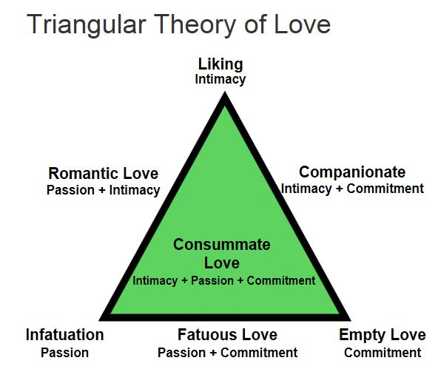
- Know how to use Sternberg’s Triangular Theory of Love. (we’ll discuss it in more detail in lecture).
For example, which type of love is this?
My neighbor turns me on sexually and we have sex regularly. I know my neighbor well and we are friends. But we have no expectations of each other about the length of the relationship or anything else.

