Study Guide Chapter 3 nb : Start with 3.2 Cells of the Nervous System
- There are Glial cells and Neurons. Which is involved most directly with information transmission? Which provides a supportive role for the other?
- The nucleus of the neuron is located in the S _ _ _
- The wall of neurons are semipermeable per our text.. I’ve also seen the walls referred to as selectively permeable. The meaning seems to be pretty close. Basically what does it mean to be selectively/semi permeable?
- The part of the neuron that looks like tree branches and usually is the part that accepts incoming signals is called the _____________
- The part of the neuron that is sometimes covered by myelin and runs from the soma to the terminal buttons (end) is called the ______
- What is the positive effect of having the myelin sheath?
- When the electrical signal goes from the soma to the terminal buttons, chemicals are released by the neuron into the gap between neurons. What are these chemicals called?
- What is the name of the gap between neurons where the substances from #7 travel?
- At rest, there is a difference in voltage between the inside and outside of the neuron. The text refers to this as the resting potential.
  - At rest, is the inside more negative or positive than the outside?
  - And by how much, i.e. by how many millivolts (mV)?
- From the handout “Action Potential of Neurons”, what is the purpose of the sodium-potassium pump?
- If the voltage difference between inside and outside of the neuron reaches a certain point, action potential is generated. What name does the text call this “certain point”? (starts with a T)
- There are many ways of defining an action potential.
  - One is the voltage level (inside compared to out) changes. How so?
  - One is that a particular type of ion rushes inside during the action potential. What ion rushed in?
- We know that a bullet will travel the same speed regardless of how hard you pulled the trigger, as long as the force on the trigger was sufficient to release the hammer. There is an analogy with the generation of an action potential. What is the name for this phenomenon? In other words, an action potential is said to be _____ or _______
- Agonists help or hinder (circle one) a particular neurotransmitter, while antagonists do the opposite.
- If you are depressed you could take a class of drugs called SSRIs. How do they work?
- Acetylcholine, Dopamine, GABA, Serotonin are all ___________________.
- The central nervous system consists of the ___________ and the _______ ________.
- The autonomic nervous system is composed of what 2 divisions? Which one is activated when a bear comes at you? Which one is synonymous with the “fight or Flight” response?
- What do motor neurons do? What do sensory neurons do?
- What is the process called whereby sensory neurons send information to the spinal chord but the signals, instead of going up to the brain, go right back out to the muscles via motor neurons? This process allows you to respond much quicker than you could if the signal went all the way to the brain.
- If my right arm hurts, which side of the brain gets that information?
- The left and right hemispheres are separated by a thick band of fibers called the
C ___________ C _________
- What is a split brain patient?
- I’ll explain the effects of a split brain when a patient is shown an object and asked what he saw and asked to pick it out with left/right hand. Text doesn’t do this at all.
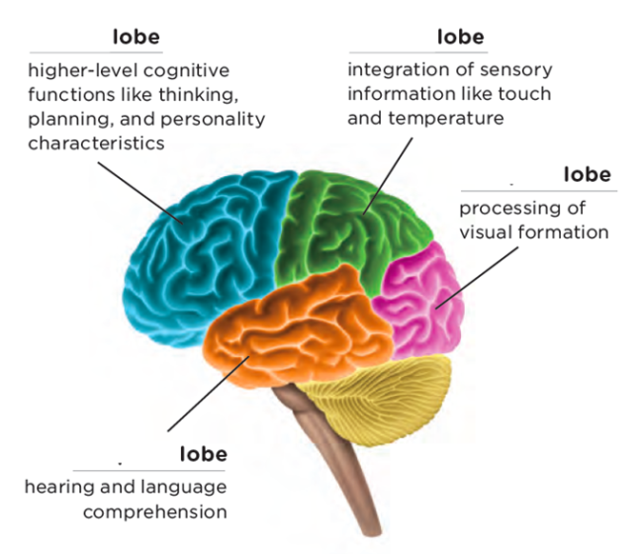
- What is the cerebral cortex?
- What is the advantage of having a cortex that is rippled? (see handout)
- Identify the 4 lobes of the brain as shown in the picture
- Who was Phineas Gage?

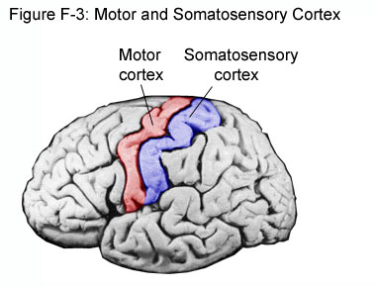

- See the pic above: What purpose does the motor cortex serve? Here is an except from wikipedia: A simple view, that dates back to the earliest work on the the motor cortex, is that neurons in the motor cortex control movement by a feed-forward direct pathway. In that view, a neuron in motor cortex sends an axon or projection to the spinal cord and forms a synapse on a motor neuron. The motor neuron sends an axon to a muscle. When the neuron in the cortex becomes active, it causes a muscle contraction.
- Know that the sensory cortex receives information from sensory neurons.
- What is an important purpose of the occipital lobe?
- What brain structure is part of the limbic system and helps regulate sexual behavior and motivation?
- There are PET scans, fMRI, MRIs, and CT scans. Which ones can show the “process” of the brain, ie. Show the brain working in real time? Which ones just shows structural stuff, like a tumor or hole?
- If I wanted to measure the electrical activity of your brain, what technique/thing would I use?
- Neurotransmitters are generally in the brain and have localized effects. In contrast, _______ travel through the bloodstream to do their work and their effects are widespread and longer lasting.
- What gland sits on top of the kidneys and releases hormones when we are stressed?
- What are the female gonads? What are the male gonads? What hormones do they secrete?

Updated S2020

