Study Guide Chapter 5 Sensation and Perception[1]

Read: Entire Chapter expect those section listed immediately below.  
In book section 5.4, skip these sections: Pitch Perception, Sound Localization, Hearing Loss  
In book section 5.5, skip these sections: Touch/Thermoception, Pain Perception, Vestibular Sense.

Read Handouts: 2 Illusions, Monocular Depth Cues, Perceptual Constancies, and Weber’s Law.Hearing

1. What is the difference between sensation and perception?
2. Transduction is the job of the sensory receptors. What does that mean? I.E. what do they have to do?
3. If an image is flashed to my eyes but is flashed too quickly for me to consciously see it, that message is said to be a S _ _ _ _ _ _ _ _ _ message. Or another name for it would be S _ _ _ _ _ _ _ _ _ stimuli. (same words in both blanks)
4. If you can’t detect a sound because it wasn’t loud enough, and this happens many times, it is because the sound is below your  
    a _ _ _ _ _ _ _ t _ _ _ _ _ _ _.
5. Assume you play 2 tones and I can’t tell which is louder. Gradually you increase the decibels of one until finally….I CAN tell which one is louder. Right at that point…that difference in decibels is said to be the J _ _ _ N _ _ _ _ _ _ _ _ _ difference.
6. 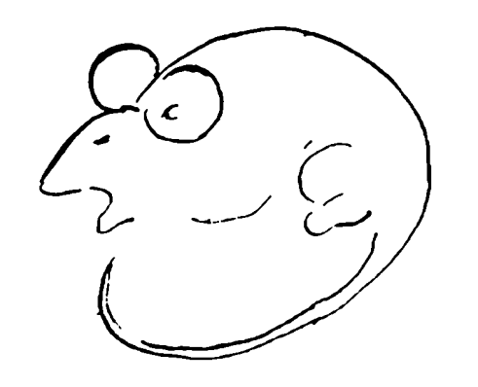Assume it takes a sound that is 50 db to detect it is louder than a sound that is 40 db. How loud would a sound have to be in order to detect it is louder than a sound that was 100 db? (see Weber’s law handout)
7. If you were shown images of rats and then asked what this was, you would likely say it was a rat. Which type of processing would you have used (top down or bottom up)?   
   If you looked at the image without having seen any prior images and replied to the question of “what is it” by saying “it could be either a rat or a man”. What type of processing would you have used? (top down or bottom up)?
8. In the movie Jurassic Park, the kids are told “don’t move, it can’t see you if you don’t move”. This is a good example of S _ _ _ _ _ _ A _ _ _ t _ _ _ _ n .
9. What’s up with this thing called inattentional blindness?
10. What basic principle of light distinguishes these 2 waves?  
    W _ _ _ L _ _ _ _ _
11. Brightness depends on what factor of light waves? Color depends on what factor of light waves?
12. What part of the eye gets bigger in dim light? Why?
13. 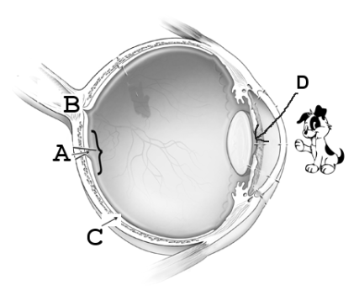In the image at the right. Identify the following structures:

A is the F _ _ _ _   
B is the B_ _ _ _ S _ _ _ of the O _ _ _ _ N _ _ _ _  
C is a part of the R _ _ _ _ _  
D is the hole that light waves go through. It is called  
 the P _ _ _ _.

1. Our retina contains rods and cones.

Which is responsible for seeing color and fine details?   
Which is responsible for seeing in dim light?  
Which lie in the fovea? _________________

1. Which theory of color vision says that we see color because the brain recognizes color by interpreting the precise patterns of excitement among 3 types of cones? What theory of color vision explains after-images?
2. In what one basic way are monocular cues different from binocular cues for depth perception?
3. Hold your hand out as far as you can, and make a fist with your thumb up. Then look at it with first left eye only and then right eye only. Then quickly go back and forth – left eye and then right eye and back etc. You will see your thumb “jump” . Now bring your hand in closer and do the same. Your thumb will “jump” as well. Question: in which case does your thumb jump farther? Far out or close up? And what is this depth cue called?
4. I want to add a second binocular depth cue: convergence. Hold your hand out with thump up and both eyes looking. Bring your thumb in slowly until it is very close. What do your eyes do as your thumb comes in?
5. What is linear perspective? Know the other monocular depth cues as well from the handout.
6. Place the following body parts in the order in which they are impacted as sound waves are turned into nerve impulses. 3 bones, hair cells, oval window, eardrum, fluid-filled cochlea).
7. Olfaction is our sense of S _ _ _ _, and Gustation is our sense of T _ _ _ _.
8. If you are smelling a skunk, does that mean you have “skunk molecules” in your nose? Why or why not?

[](https://www.google.com/url?sa=i&rct=j&q=&esrc=s&source=imgres&cd=&cad=rja&uact=8&ved=0ahUKEwjVleLe56fUAhVC-GMKHUVWB5IQjRwIBw&url=https://en.wikipedia.org/wiki/Figure%E2%80%93ground_(perception)&psig=AFQjCNHitktICSfYlM4UPF9dM32oSR84fw&ust=1496790090382478)

1. See the pic at the right. We can’t tell if it is a white vase or 2 black faces. The designer is messing with our need detect what relationship?

Choose from these Gestalt Organizing Principles in answering 24-27. Continuity, similarity, proximity, closure

1. The 9 squares at the left as seen as individual objects, but the 9 squares at the right as seen as one big square because of the Gestalt Organizing Principle of ________________



1. If you look at the figure at the right, you are likely to see a shape in the middle because of the Gestalt Organizing Principle of ______________.
2. We see the object at the right as 2 lines that cross rather than 4 individual lines that meet in the center. We see it that way because of the Gestalt Organizing Principle of__________________



1. We see a triangle in the figure at the right, even though none exists. We do this because of the Gestalt Organizing Principle of ________.
2. 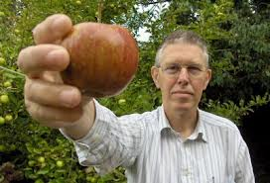See the image of the man holding an apple. The apple is making a larger retinal image than the man’s head. What perceptual constancy can explain why the brain doesn’t perceive this as a huge apple? (see handout)

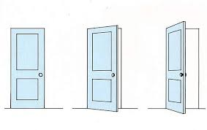

1. See the picture of 3 doors. The brain perceives the right door as the same shape as the others even though the retinal images are not the same. What perceptual constancy is responsible for this? (see handout)
2. 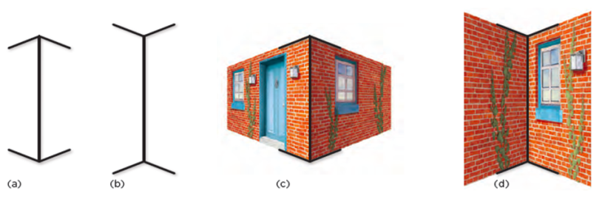How to explain the Muller-Lyer illusion (from handout): see the figure at the right.
   1. Which line (A or B) does the brain interpret (perceive) as farther away?
   2. It perceives it as farther away because it is most often associated with image (C or D).
   3. If 2 lines are the same size (same sized retinal image) and one is perceived as farther away, then it must be (longer, shorter).
3. 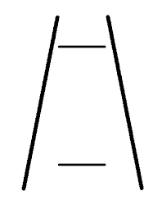The figure at the right is called the ponzo illusion (see handout). The top line looks longer but really isn’t. Why does it look longer?
4. 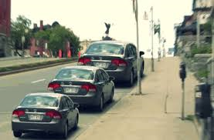Look at the image at the right. The top car appears much bigger. Is it really? Why does it appear bigger when it isn’t?
5. We know that sometimes our experiences prepare us to perceive things in a certain way. If you look at the top row and go from left to right, the last image will be seen as a man’s face. If you do the same with the second line, the last image will be seen as a mouse. Is this an example of top down or bottom up processing?
6. See the figure below. Hold the image at arm’s length, close your right eye, and while looking at the orange with your left eye, bring the paper slowly closer to your face. If you do as directed, at some point, the apple will disappear. This happens when the image of the apple falls on you B _ _ _ _ S _ _ _

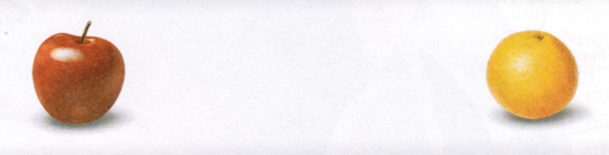

1. Updated spring 18